Warning – CCD Drive Control Malfunction – CGEA1.3

Functional Description

The purpose of the CCD Drive Control Malfunction display is to inform the driver of a failure in the vehicle’s variable damping system (a.k.a. Continously Controlled Damping, or CCD) and also called DSS (Driver Select Suspension), which employs user-selectable modes. The Vehicle Dynamics Module (VDM) is the module that controls the CCD function. This STSS triggers W1027 (Drive Control Malfunction Service Required).

Starting with U55x and C519, there is a new ABS hosted Selectable Drive Mode Control function. Programs that have this new SDM STSS (Selectable Drive Mode Control Function – CGEA 1.3_vx.x.doc) and have a VDM should use this Warning – CCD Drive Control Malfunction STSS. This is because the legacy STSS that controlled W1027 (CCD Control Function w Adaptive Drive - CGEA1.3_vx.x.doc) has been obsoleted with the new ABS hosted SDM. This STSS is necessary since it is still necessary to display a CCD fault, and the SDM STSS does not handle this fault.

This STSS re-uses an existing DExx configuration bit, CCD_Cfg. This bit was also used in CCD Control Function w Adaptive Drive - CGEA1.3_vx.x.doc, but as explained above, these 2 STSS’s are mutually exclusive.

The CCD Drive Control Malfunction Warning correlates the CCD_B_Falt signal from the VDM and the operational mode to display the appropriate warning in the message center.

Interfaces

Interface Context Diagram (I/O Block Diagram)
Figure 1 Warning – CCD Drive Control Malfunction Context Diagram
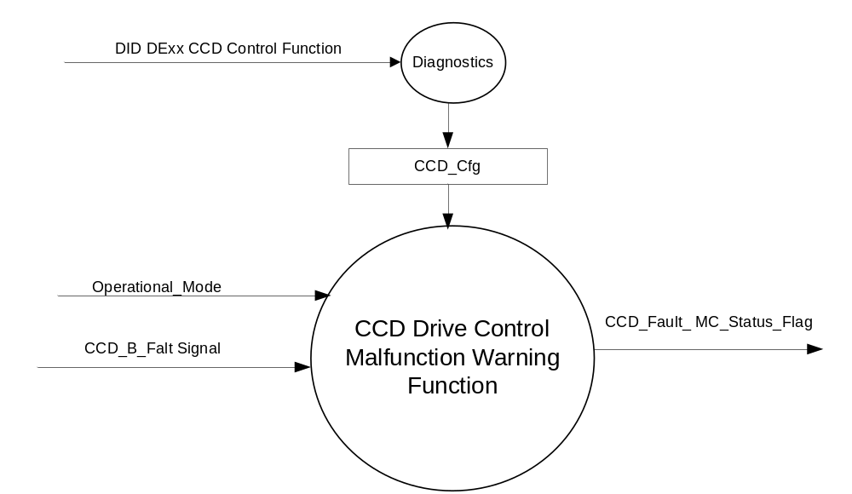

Inputs
      - INTERNAL:
            - Operational_Mode
            - CCD_Cfg
- MUX message from the CAN bus

- CCD_B_Falt Signal
Signal Name | Size  (bits) | Detail | Units | Res. | Offset | State  Encoded | Min | Max
CCD_B_Falt | 1 |  | SED | 1 | 0 |  | 0 (0x0) | 1 (0x1)
 |  | No |  |  |  | 0x0
 |  | Yes |  |  |  | 0x1

Outputs
- CCD_Fault_MC_Status_Flag that is used to control the Warning displayed in the message center.

Function/Performance

Operational Modes

Mode | Differentiating Vehicle Conditions
Sleep Mode | OFF
Limited Mode | OFF
Normal Mode | CCD Warning Function Text Messages ON / OFF
Crank Mode | CCD Warning Function Text Messages ON / OFF

The above table references the setting of the Warning flag as per this section. However, the actual Warning display operational modes are displayed in the Message Center section of this SPSS.

Voltage Levels

Refer to the Cluster Features Table located in the Operational Modes and Voltage Range Strategies Section of this SPSS

Human-Machine Interface

Visual

Indicator Graphics / Display Format

Refer to Message Center Function description reference "Global Message List.xls" file Message ID W1027.

1.3.3.1.2 Indicator Color Coordinates

Reference section COLOR & ILLUMINATION REQUIREMENTS (GRAPHICS)

1.3.3.1.3 Indicator Characteristics

Refer to Message Center X Display_Y Button Interface Section, where X and Y are appropriate values in this document.

Audio

The Message Center Informational Warning Chime is associated with this Warning.

Switch Control Logic

Consumer access to the Warning shall be as specified in the message center basic functionality display as specified in Message Center X Display_Y Button Interface Section, where X and Y are appropriate values in this document.

System Accuracy

Within 100 msec of receiving a message that results in a change of state the cluster will update the display to the proper state.

Operation: Performance and Functional

Subsystem Algorithm Flowchart / State Diagram

- State Matrix for Warning – CCD Drive Control Malfunction
Operational_Mode | CCD_Cfg | CCD_B_Falt Signal | CCD_Fault_ MC_Status_Flag
Normal or Crank | Enabled (0x1) | Yes (0x1) | ACTIVE
Normal or Crank | Enabled (0x1) | Missing as per 1.4.1 | ACTIVE
All Other Cases |  |  | INACTIVE

Operation Description (supports algorithm flowchart /state diagram)

- For definition of how the Message Center arbitrates and displays Active warnings, see the Warning / Alert Display Logic Diagram, located in the Message Center – X Display with W Button Interface section of this SPSS (where X and W are appropriate values in this document).
- W1027 will be the text used by the Message Center when it displays this ACTIVE Warning.

Function Safety Classification (EMC)

Class B

Memory Storage

Parameter Name | Description | Value at  Battery Connect | Value at  Module Wake-up
CCD_Fault_MC_Status_Flag | Used to control the state of the warning to the Message Center arbitrator | INACTIVE (0x0) | INACTIVE (0x0)
CCD_Cfg | Configures cluster to allow CCD Drive Control Malfunction warning for a VDM fault or missing message. Also allows a missing message DTC for the VDM. Set to Disabled at Cluster Supplier Manufacturing Plant. | Use Stored Value | Use Stored Value
CCD_B_Falt Signal | Input signal sent from the VDM to the IPC | No (0x0) | No (0x0)
Operational_Mode | 4 state indicator for cluster operational mode | Limited | Limited or Normal or Crank

Prove Out

No.

Reconfigurable Telltale

No.

Message Center Msg

Refer to Message Center Function description reference "Global Message List.xls" file Message ID W1027.

Error Handling

Missing Message/Undefined Data Strategy

The signals will be declared missing as per the Diagnostics section of this SPSS.

DTCs states and history will be determined as per the Diagnostics section of this SPSS.

If the CCD_Cfg is DISABLED, the cluster shall never log a missing message DTC due to this feature.

Diagnostics

Self Test

None

Engineering Test Mode

Reference section “Dealer / Engineering Test Mode (ETM)”

Part II Performance

Supported Diagnostic Trouble Codes (DTCs)
DTCs shall be logged as per the diagnostic section of this SPSS*.
DTC | Description | Configuration
C12200 | Lost Communication with Vehicle Dynamics Control Module | CCD_Cfg = Enabled (0x1).
C41682 | Invalid Data Received From Vehicle Dynamics Control Module - No Update | CCD_Cfg = Enabled (0x1).
* If the missed signal has an _UB signal, the NO Update DTC is to be logged.
Otherwise, the Lost Communication DTC is logged.

Mod Conf (DID DExx)
Block  Num | Block Description | Byte(s) | Bits | State: Description | "0" | "1" | Default | Comments/Information
PACKETED BLOCKS
$xx | Option Content (B&A) | * | * | CCD Control Function | Disabled | Enabled | Disabled | Disabled means the VDM is not present in the vehicle. Enable whenever the VDM is present in the vehicle.  Note, this config is re-used from STSS “CCD Control Function w Adaptive Drive - CGEA1.3_vx.x.doc” since that STSS is obsoleted on vehicles with ABS hosted SDM.
*Byte and bit location to be identified in Part II Specification for this cluster

Reference Specification

IS-0001 WARNINGS/INDICATORS/DISPLAYS PROVEOUT
IS-0052 OPERATING VOLTAGES - FUNCTIONAL/PERFORMANCE
IS-0069 FUNCTIONAL IMPORTANCE CLASS
IS-0324 WINDSHIELD & OTHER REFLECTIONS
IS-0327 WARNING INDICATOR EVALUATION
IS-0379 NORTH AMERICAN WARNINGS AND INDICATORS STRATEGY

IL-0017 TELLTALE AND INTERIOR ILLUMINATION – COLOR AND INTENSITY
IL-0019 GENERAL ILLUMINATION DIMMING
IL-0021 CRAFTSMANSHIP – DISPLAYS
IL-0022 GENERAL ILLUMINTATION COLOR
IL-0023 CLARITY/LEGIBILITY/READABILITY/VISUAL CONTRAST
IL -0043 OPERATIONAL ENVIRONMENT FUNCTIONALITY
IL -0045 COLOR
IL -0047 TELLTALE, INDICATOR AND DISPLAY LIGHT INTENSITY
IL -0048 ILLUMINATION ACCEPTABILITY

03-0661 PLACEMENT: CONTROL AND DISPLAY LOCATIONS
03-0662 PLACEMENT: LOGICAL GROUPING FUNCTION AND USAGE
03-0664 PLACEMENT: DOWN VISION TO COMPONENTS WITH HIGH VISUAL DEMAND
03-0665 PLACEMENT: EXPECTED LOCATIONS OF CONTROLS AND DISPLAYS VDS
03-0670 INTERIOR VISIBILITY
03-0671 INTERIOR VISIBILITY: REFLECTIONS FROM COMPONENTS & SURFACES
03-0672 INTERIOR VISIBILITY: REFLECTIONS IN DISPLAYS
03-0673 INTERIOR VISIBILITY: VISUAL OBSCURATIONS
03-0674 INTERIOR VISIBILITY: ILLUMINATION CONTROLS / DISPLAYS
03-0675 INTERIOR VISIBILITY: VEILING GLARE
03-0677 INTERIOR VISIBILITY: SUNLIGHT WASHOUT
03-0681 IDENTIFICATION: CHARACTER AND SYMBOL SIZE
03-0682 IDENTIFICATION: LEGIBILITY
03-0685 IDENTIFICATION: SYMBOLS, ABBREV FOR CONTROL
03-0721 LOGIC OF OPERATION: OPERATIONAL STEREOTYPES
03-0722 LOGIC OF OPERATION: INTERPRETATION
03-0723 LOGIC OF OPERATION: USE OF SYSTEMS WITH VISUAL DISPLAYS

Revision History

SPSS Module Revision History

Revision Level | Name | Change Description | Date
1.0 | S. Watkins | Initial release. This is per John Keller/Ben Bulat per DI CC on 7/21/2016. On vehicles with ABS hosted Selectable Drive Modes (SDM) and a VDM, this STSS is necessary to trigger a VDN fault warning. | 7/23/2016

